

**University of Nairobi**

**School of Engineering**

**DEPARTMENT OF GEOSPATIAL AND SPACE TECHNOLOGY**

**Development of a Web based Spatial Information System for Non-Governmental Organizations in Nairobi County**

Research Proposal submitted for the Degree of Master of Science in GIS, in the Department of Geospatial and Space Technology of the University of Nairobi

**BY**

**JACKLINE RATENG**

**F56/88421/2016**

SIGNATURE…………………………DATE…………………………………

**This Research proposal is submitted with our approval as University supervisor (s):**

**SUPERVISOR:**

PROF. G.C MULAKU SIGNATURE…………………………….DATE………………..…………….

**CHAIRPERSON:**

DEPARTMENT OF GEOSPATIAL AND SPACE TECHNOLOGY

SIGNATURE…………………………DATE………………………………………………………

**May, 2018**

# 

# Declaration

I, Jackline Rateng, hereby declare that this project proposal is my original work. To the best of my knowledge, the work presented here has not been presented for a proposal in any other university.

JACKLINE RATENG 16/05/2018

Name of Student Date

This project proposal has been submitted for review with my approval as university supervisor.

PROF. G.C MULAKU 16/05/2018

Name of Supervisor Date

# Acknowledgement

I would like to acknowledge the guidance of Prof. G.C. Mulaku, Dr. Faith Karanja and Dr. Siriba for their assistance during the preparation of this proposal.

Table of Contents

Declaration 1

Acknowledgement 2

Abstract 6

CHAPTER 1: INTRODUCTION 7

Background 7

1.2 Problem Statement 8

1.3 Objectives 8

1.4 Justification for the Study 8

1.5 Scope of work 9

CHAPTER 2: LITERATURE REVIEW 11

2.1 About NGOs 11

2.2 NGOs in Kenya 12

2.3 Technology Aspect 13

2.4 Web GIS Development Methodologies 14

2.5 Case Studies 16

2.5.1. Karamoja NGO Mapping Report, UGANDA 16

2.5.2. Mapping the UK NGO Development Sector 18

CHAPTER 3: MATERIALS AND METHODS 21

3.1 MATERIALS 21

3.1.1 Data 21

3.1.2 Tools 21

3.1.3 Methodology 21

PROJECT WORKPLAN 24

PROJECT BUDGET 25

REFERENCES 26

Najjar F. (2017),*Why is Egypt's new NGO law controversial?* Aljazeera 31/05/2017 [ accessed on August 23,2018] 27

List of Figures

Figure 1.1 Map of Nairobi County 9

Figure 3.1: Showing Alesheikh GIS Development Cycle 22

Figure 3.2: Showing a three tier client/server architecture 23

# Abstract

When the Non – Governmental Organisations (NGO) sector in Kenya was started there were no quality standards in the sector that would allow distinguishing independent and active NGOs working with human rights and social development issues from those being used as fronts for funding terrorism, money laundering and promotion of regime change/civil unrest through propaganda or otherwise.

Over the recent past, Governments across all continents have begun perceiving NGOs as a threat to political, economic and social control over their countries. This shift can be attributed to the kind of foreign policy pursued by former US president George W. Bush through interventions in Iraq and Afghanistan that resulted in regime changes. Currently, the Kenyan government is suspicious of NGOs as it is unable to monitor their source of funding, whether they are active or not and spheres of influence/activities within their areas of operation

The objective of this project is to create a Geodatabase of NGO’s as well as a web based application for querying, interaction, visualisation and submission of reports for analysis of their socio-economic impact.

A customised version of the GIS Development Life Cycle by Alesheikh will be used as the baseline methodology to develop the Web GIS system. The reason for using this particular model is that it has been tried and tested over time and has been successful in the implementation of Web GIS projects.

A fully functioning web portal and a geodatabase of NGO’s is expected to be realised upon completion of this project. This web portal and geodatabase can be used by the government and security officials to query the existence of a particular NGO, area of operation and economic impact from the uploaded reports. It can also be used to monitor the activities of NGOs by ensuring that they only carry out the activities that they were registered to do and in the registered location. In addition, the web portal may also be used by the general citizenry to understand the activities of NGOs promoting trust between them and the people they intend to serve. Apart from enhancing trust, when the citizens are aware of the NGOs based in their localities they will be able to participate in volunteer work and in the identification of genuine NGOs from dubious ones that are being used as fronts for promoting undesirable agenda.

# CHAPTER 1: INTRODUCTION

## Background

There are thousands of Non-Governmental Organisations (NGOs) in Kenya, nine thousand

Seven hundred and twenty-eight (9,728) registered NGOs to be precise but only seven thousand two hundred and fifty-eight (7,258) that are active (Daily Nation Kenya, 2015). In addition, seventy-seven thousand two hundred and ninety-five (77,295) people, majority being Kenyans have been employed by NGOs. In the 2013/2014 financial year alone one thousand eight hundred (1800) NGOs were registered most of them dealing in health, education and services, with the majority being located in Nairobi County (13.4%) and the least (0.7%) in Lamu County. (Daily Nation Kenya,2015).

When the NGO sector in Kenya was started there were no quality standards in the sector that would allow distinguishing independent and active NGOs working with human rights and social development issues from those being used as fronts for funding terrorism, money laundering and promotion of regime change/civil unrest through propaganda or otherwise. Further, there were no measures put in place to encourage NGOs accountability, making them a channel for misappropriation, counterfeiting and contraband, some even being unable to explain the sources of their funds. For example, in 2017, five hundred (500) NGOs in Kenya were de-registered for being unable to explain the source of their funding (Daily Nation Kenya, 2015). Moreover, there is lack of public information about these organisations which has resulted in increased distrust and indifference towards NGOs among citizens.

By mapping NGOs in Kenya, this project hopes to provide a platform that will enable identification of all NGOs registered within a specified geographic location and their mandate thus increasing transparency.

## 1.2 Problem Statement

Currently, the government is suspicious of NGOs as it is unable to monitor their location, source of funding, whether they are active or not and spheres of influence/activities within their areas of operation. This suspicion has led to increased regulation hampering the activities of NGOs in the country.

Apart from security related reasons, the citizens wishing to volunteer in NGOs as well as the donors may wish to find out information about the existence of NGO and its projects activities within a particular region. Currently, this is only possible by contacting the NGOs directly.

The project aims to increase the much needed transparency that will enable re-establishment of trust among the Government, NGOs and citizens. This can be achieved through creating a Geodatabase of NGOs and a web based application for querying, interaction, visualization and submission of reports for analysis of their socio-economic impact. Similarly, the project will enable identification of dubious NGOs that have been set up as fronts for other purposes.

## 1.3 Objectives

The objective of this project is to create a Geodatabase of NGOs as well as a web based application for querying, interaction, visualisation and submission of reports for analysis of their socio-economic impact.

The specific objectives are:

1. To create a Geodatabase of NGOs
2. To create a web based application for querying, interaction, visualisation of spatial and attribute information about NGOs.

## 1.4 Justification for the Study

The NGOs web portal and geodatabase can be used by the government and security officials to query the existence of a particular NGO, its location, area of operation and economic impact from the uploaded reports. It can also be used to monitor the activities of NGOs by ensuring that they only carry out the activities that they were registered to do and in the registered location.

It will also be used by the general citizenry to understand the activities of NGOs promoting trust between them and the people they intend to serve. Apart from enhancing trust, when the citizens are aware of the NGOs based in their localities they will be able to participate in volunteer work and in the identification of genuine NGOs from dubious ones that are being used as fronts for promoting undesirable agenda.

The developed geodatabase and geoportal of NGOs could also be integrated with the PISCES (Personal Identification Secure Comparison and Evaluation System), a [border control](https://en.wikipedia.org/wiki/Border_control) database system largely based on [biometrics](https://en.wikipedia.org/wiki/Biometrics), and National Registration Bureau (NRB) systems for registration of foreigners entering the country as employees/volunteers of NGOs and to monitor the activities of foreign nationals and establishing whether work permits have been issued for all the foreign employees.

## 1.5 Scope of work

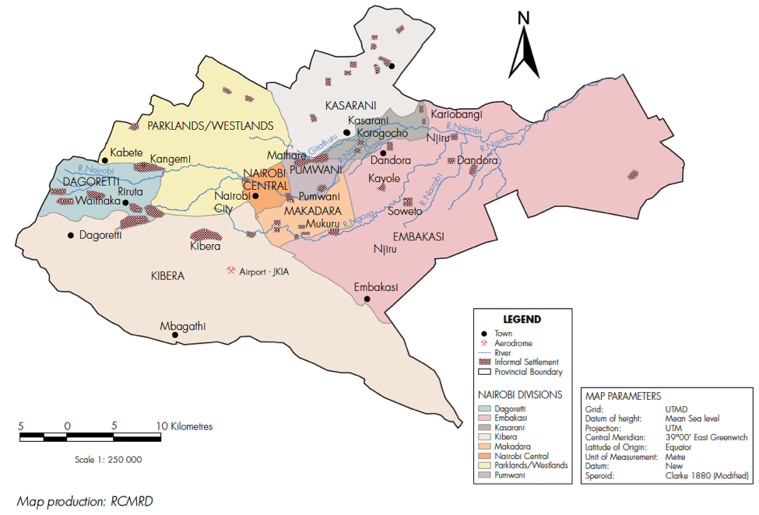

Figure 1.1 Map of Nairobi County

The scope of the project will involve establishing a geo-database and an interactive web based application for visualisation and interaction with the geo-database as well as display of other information related to NGOs within Nairobi County over the past five years. The geodatabase will include the following attributes: Name of organisation, date of registration, country of origin, area of operation and name of partners and donors. The system will also be able to carry out certain analysis capabilities such as: search, filter, basic report generation and download capabilities.

# CHAPTER 2: LITERATURE REVIEW

## 2.1 About NGOs

There are as many definitions of Civil Society Organisations (CSO’s) and Non – Governmental Organization (NGO’s) as the people who attempt to define them. According to Wanjiru Gikonyo of Katiba Institute, there is no single right definition; however, common themes run through most definitions. The following definitions will be adopted for the purposes of this project:

A Non – Governmental Organization refers to an association, society, foundation, charitable trust, non-profit corporation, or other juridical person that is not regarded under the particular legal system as part of the governmental sector and that is not operated for profit, if any profits are earned, they are not and cannot be distributed as such. It normally does not include trade unions, political parties, profit distributing cooperatives, or churches, which are usually regulated under separate legislation (World bank, 1997).

The London School of Economics and Political Science(LSE,2001) defines civil societies as a sphere of institutions, organizations and individuals located among the family, the state, and the market, in which people associate voluntarily to advance a common interest. It includes but is not limited to various forms of NGOs, trade unions, political parties, cooperatives and churches.

In the recent past, governments across all continents have begun perceiving NGOs as a threat to their political, economic and social control over their countries. Katja Drinhausen and Günter Schucher from the German Institute for Global and Area Studies (Drinhausen *et al*, 2010) explain the shift as attributable to the kind of foreign policy pursued by former US president George W. Bush through interventions in Iraq and Afghanistan that resulted in regime changes. The West’s solidarity with the colour of revolutions in Georgia, Ukraine, Central Asia and the Middle East all led to government’s justification of resistance to external democracy. These incidences have led to the shrinking of the NGOs space in countries and an emergence of mistrust between the government and the NGOs. To put it in perspective, CIVICUS, a global organization for citizen participation highlighted ninety six (96) significant restrictions on the rights of NGOs between June 2014 and May 2015.These restrictions are not only present in Russia, Turkey, India and China but in over sixty (60) countries, with the core concern being, cutting the flow of money to domestic organizations or placing the flow of money under state control.

In many countries, and genuinely so, national security and especially the war on terror are used to ban democratic organizations. A good example is in Egypt where on 30th May 2017, their President, Abdel Fattah el-Sisi , signed into effect a law that restricts the operations of more than forty seven thousand NGOs (Najjar,2017). This general suspicion is so extreme that the country has become a military dictatorship. Ethiopia is also another country where several NGOs have been closed down by the state or forced to leave (Dupuy *et al* 2015).

## 2.2 NGOs in Kenya

Civil societies in Kenya, of which NGOs are a part, have their origins in African communal traditions and values, early Christian missionaries and British colonization during the 19th century (Chemngetich, 2009). In the early African tradition and value system, a number of families had organized themselves into sub-units and units that would appoint elders who would be responsible for leading the community and defending the old and the vulnerable members. This tradition was augmented by educational and social welfare institutions that were established by Christian missionaries in the 19th century and finally as welfare associations that were used by Africans to advocate for rights and express dissatisfaction with colonial government rule and treatment. Such organizations included: Kavirondo Taxpayers Welfare Association, East African Association, Taita Hills Association and Ukambani members Association (Jilo, 2009). The post-independence government continued to further popularize the self–help spirit, commonly referred to as harambee.

From the above explanation it is apparent that civil society organizations are vital to the core existence and sustainability of the Kenyan Society. Under the Kenyan Government, they have continued to complement the work of the government, provide services and advocate for reforms and democracy.

In Kenya, the NGO coordination board, which is the body responsible for registration and deregistration of NGOs, was in 2015 taken to court over deregistration of the Kenya Human Rights Commission (KHRC) (Nation,2015). On 15th August 2017, Mr Fazul Mohammed, the executive Director, through a press statement, announced the deregistration of five hundred NGOs, which came a week after the 8th August elections.

NGOs in Kenya have in various occasions successfully contained and managed crises in the country. A good example is the Kenya RedCross which during the 2013 Westgate terror attack mobilized funds, through the “we are one campaign”, which were used to pay for medical bills for the victims of those attacked as well as provide psychological counseling to those affected. The Red Cross has also been known to come through during natural disasters like floods and drought and other humanitarian emergencies. Another good example is Women Fighting Aids in Kenya (WOFAK) which was established by women who were HIV positive. It mainly deals with health, orphans and vulnerable children, economic empowerment and advocacy in HIV related issues.

## 2.3 Technology Aspect

The project will make use of the technological foundations provided by the web 2.0 to present information regarding NGOs. With the advent of the internet and the web 2.0, interactive websites have become the standard for web development (O’Riley, 2004**).** GIS technology has taken advantage of this opportunity to produce dynamic interactive web-maps that allow for zoom, pan and search functions with high cartographic standards. Previously, most digital information was confined for use on PCs. Such information could not be shared by other organizations. GIS analysts would access data from powerful PCs that were often connected to a file server and specialized software was required to view or manipulate the data, narrowing the audience that could benefit from the information.

In the 1900s people began posting static maps and other geographic maps on HTML pages. However, peoples soon realized the potential for interactive maps and it was a game changer (Plewe, 1997). The early, dynamically drawn web maps experienced challenges with speed and scalability especially during simultaneous user access, but as web mapping matured, the concept of tiling map images from pre-generated caches was adopted. Tiling of images involves pre-drawing all possible map extents at reasonable sets of scales, and after caching, serving out the images as a tiled mosaic. This way each tiled map request is satisfied exponentially faster than it would take to serve the map dynamically, allowing the server to accommodate hundreds of simultaneous users (MacWright *et al*, 2010). Notable examples of where tiling has been used include Google maps and OpenStreetMaps.

The foundation technologies enabling web 2.0 are Asynchronous JavaScript and XML (AJAX), RSS, Eclipse, Microsoft Silverlight and Adobe Flash. Most applications on the Web 2.0 are based on the decentralized download methodology in which each downloader of content is also a server, sharing the workload and making heavily demanded content more accessible. A good example being Bit Torrent (Rouse, 2015).

## 2.4 Web GIS Development Methodologies

Unlike conventional software systems, methodologies for web GIS have not been around for a long time and are mostly project specific (Ananda *et al*, 2016). Web GIS began gaining widespread popularity in the mid-2000s and is now slightly over a decade old. The technologies supporting these systems have been rapidly evolving with widespread adoption of open source tools and standards in their development. A few authors have published methodologies that could be used in Web GIS development. These methodologiesare presented in Table 2.1.

Table 2.1: An overview of the strengths and weaknesses of Web GIS methodologies (Adopted from Ananda *et al* 2016)

|  |  |  |
| --- | --- | --- |
| Methodology | Overview | Strengths/Weaknesses |
| Web GIS Development Cycle (Alesheikh, 2002) | A hybrid approach adapted from the waterfall model and the classical Software Development Lifecycle (SDLC). Development is split into 8 successive phases in the following order; requirements analysis, conceptual design, hardware & software survey, database design & construction, acquisition of GIS hardware & software, web GIS system integration, application development and web GIS use and maintenance | Suitable for the novice developer as it offers a simplified step by step approach. However the methodology is not practical for large projects and it does not put any emphasis on user involvement and testing which are critical components during the development of such systems. |
| Rapid GIS Development (Cavaco *et al*, 2010) | Based on Rapid Application Development methodology. Supports the rapid development of database-centric GIS applications. It is more of an implementation framework than a methodology. | Based on Rapid Application Development methodology. Supports the rapid development of database-centric GIS applications. It is more of an implementation framework than a methodology. |
| Web GIS Navigational Development Techniques | This process integrates models from Navigational Development Techniques (NDT) methodology with models from the Organizational Semiotic technique. Consists of Requirements engineering, conceptual design, navigational design, abstract interface design and implementation. Relies on formal model definitions to represent geographical concepts. | Supports the rapid development of web GIS applications. Furthermore during the requirements engineering, it introduces the use of the Organizational Semiotics to define requirements. |

Web GIS development methodologies are still being developed as the number of such projects increases. The methodologies still require adequate testing on a broad range of projects. This is not entirely possible as GIS projects are quite costly and organizations may not be willing to risk adopting processes that are not proven.

## 2.5 Case Studies

Within the vast literature of NGOs, the case study approach is the norm (Bebbington, 2004), such that works provide in-depth, often single organization accounts of NGO structure, history, organizational culture, business enterprises, local communities and NGO effectiveness in on-the-ground projects. Generally, not much attention has been paid to analyzing the geographies of NGO activities in the national and subnational levels including distribution in relation to poverty levels and amount of funding that a particular NGO can access, or even just to enable one draw general conclusions from emerging trends and patterns. The following case studies have been selected as this project will attempt to carry out a similar exercise in Nairobi, Kenya.

### 2.5.1. Karamoja NGO Mapping Report, UGANDA

The report on the Karamoja NGO Mapping was prepared, on behalf of the Karamoja Development Partners Group (KDPG), on 1st November 2016 with the support of the USAID through the Karamoja Resilience support Unit (KRSU). The main objective of the exercise was to support strengthened co-ordination and dialogue between civil societies and other stakeholders in the Karamoja region in a bid to improve analysis, collaborative learning and evidence based decision making.

The methodology used involved distributing an excel based data collection tool electronically to NGOS within the Karamoja region. The data entry form was completed and the responses electronically returned to KRSU by 92 % of all the NGOs that were contacted. The mapping done was based on the responses from the fifty four (54) NGOs out of the fifty nine (59) that had been identified and contacted. These NGOs included International, National and Faith based organisations within the Karamoja region.

From the exercise, it was possible to identify the major sources of funding, the distribution of the funds across the sectors being supported by the NGOS - with the main foci being basic service delivery and food security, the active projects being carried out by NGOs and their duration, and the distribution of projects across the districts.

Some of the findings from the exercise were:

* There are 142 active projects in Karamoja being implemented by the 54 NGOs which responded to the survey. The project durations for the various initiatives range from 1 month up to 8 years; funding ranges from $10,000 up to $55 million.

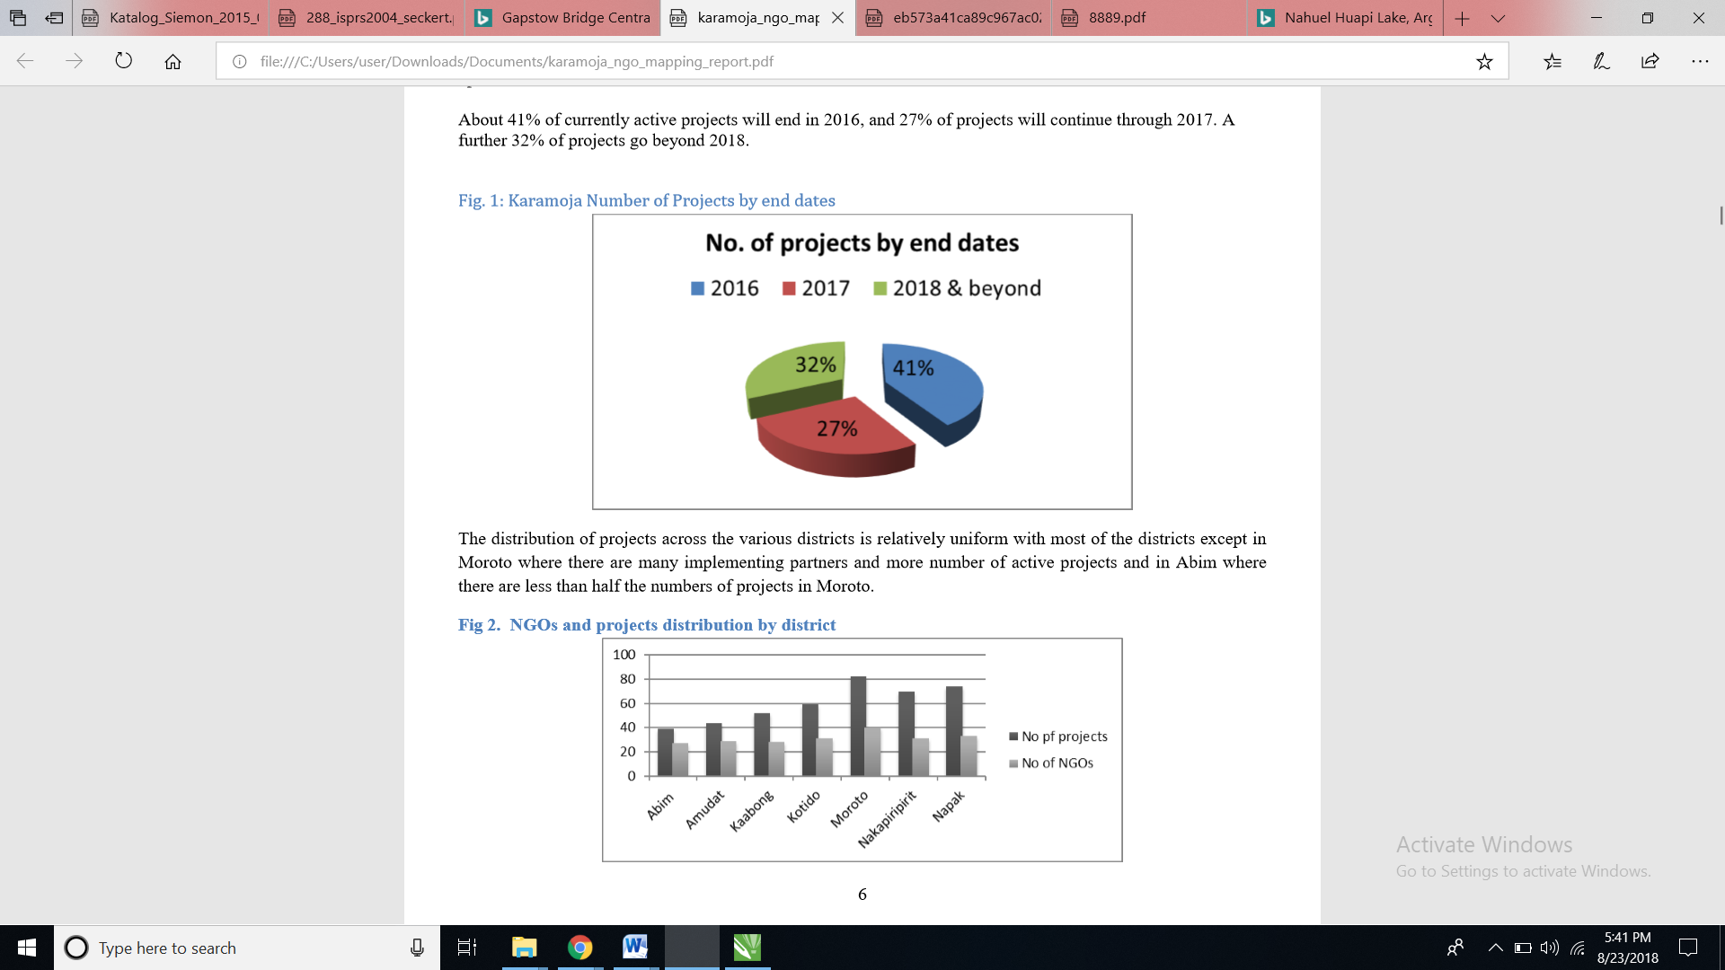

Figure 2.1: Number of projects by end dates in Karamoja

* About 41% of currently active projects will end in 2016, and 27% of projects will continue through 2017. A further 32% of projects go beyond 2018.

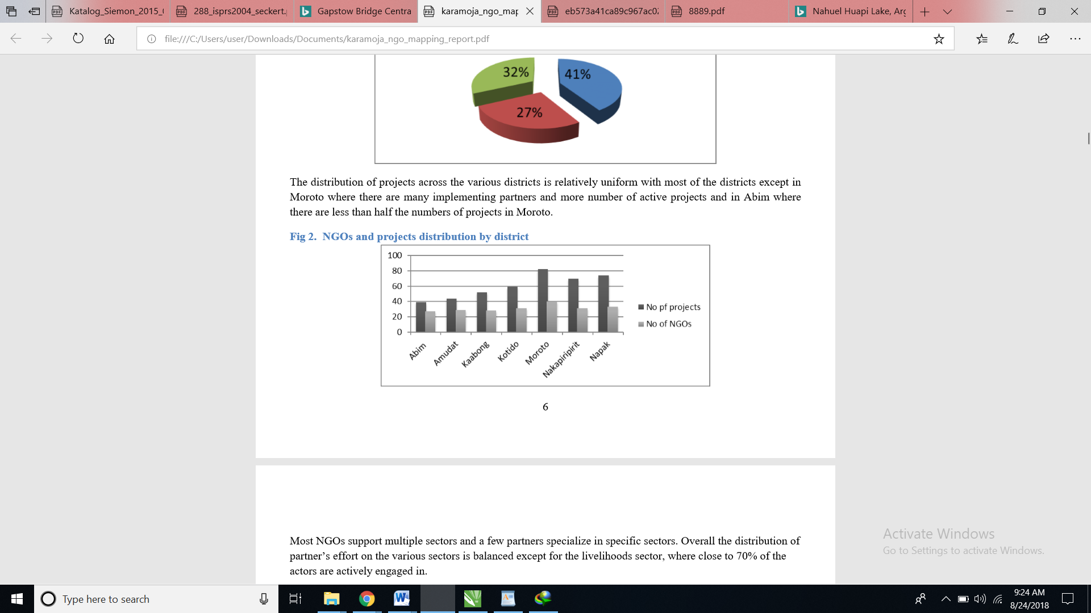

Figure 2.2: Distribution of projects across various districts in the Karamoja region

* The distribution of projects across the various districts is relatively uniform with most of the districts except in Moroto where there are many implementing partners and more active projects and in Abim where there are less than half the number of projects in Moroto.

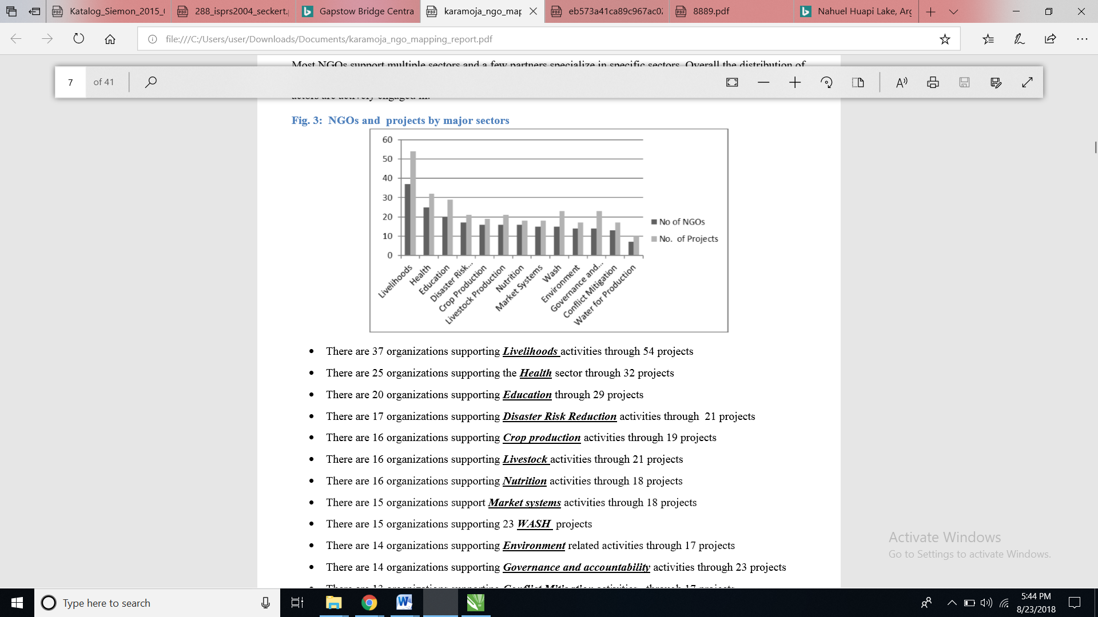

Figure 2.3: NGOs participation in various sectors in the Karamoja region

* Most NGOs support multiple sectors and a few partners specialize in specific sectors. Overall the distribution of partner’s effort in the various sectors is balanced except for the livelihoods sector; where close to 70% of the actors are actively engaged.

### 2.5.2. Mapping the UK NGO Development Sector

The report on Changes in Expenditure, Income and Income Sources for Development NGOs based in the UK was first published in October 2017.The aim of the exercise was to understand better how the development of the NGO sector in the UK works and how it collaborates with overseas partnerships and networks. The exercise was also important for understanding what supports the sector in the UK and how that support is changing. The NGO sector in the UK has grown rapidly since the 1980s but it is highly unequal in terms of its allocation of resources and geographical distribution.

To construct the database,898 development NGOs were selected after 1500 charities were screened (hereafter NGOs) from the membership lists of BOND, Scotland's International Development Alliance; South West and South Wales International Development Network; The South Yorkshire International Development Network, the Foundation for Social Improvement and Small Charities Coalition; from grantees of DFID and Comic Relief; from Hub Cymru Africa; from organisations declaring their interests in ODA and famine relief on the Charity Commission website; from a previous research project into conservation NGOs. For the selected organisations, financial data was obtained from three sources. Basic income and expenditure were available for download from the Charity Commission, the Office of the Scottish Charity Regulator and from the organisations themselves.

Some of the findings of the exercise were:

* The total charitable spending was about £68bn of which £53bn was for charities whose remit is only within the UK. Only £2.9 billion was spent entirely overseas.
* Establishment of NGOs has increased rapidly since the 1980s with the largest number of annual establishment in 2003, 2007 and 2009.

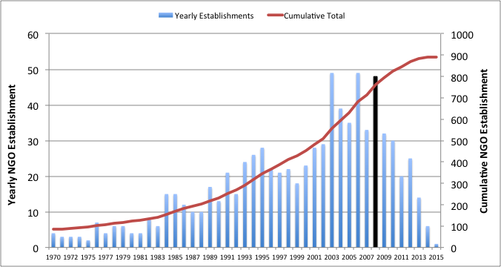

Figure 2.4: NGOs annual and cumulative establishment in the United Kingdom

* Income and expenditure by development NGOs has increased since 2004 across all class sizes in England and Wales, and in Scotland since at least 2009.
* London dominates the development NGO scene. Most of the largest organisations are found there and by far the most money is spent by organisations headquartered there. (See Figure 2.5):



**Key:**

|  |  |
| --- | --- |
|  | Annual Budget |
|  | > £3,000,000.00 |
|  | £1,500,000.00 - £3,000,000.00 |
| 1 | £500,000.00 - £1,500,000.00 |
|  | £100,000.00 - £500,000.00 |
|  | < £100,000.00 |

Figure 2.5: Distribution of NGOs in the United Kingdom

* The public is the most important source of revenue for development NGOs, providing 40% of revenues. This has increased in real terms over the last 5 years, but decreased marginally in relative importance as the sector has diversified.
* Growth in public income is not rivalrous, i.e. organisations do not seem to be fighting for the same pound. Instead they are seeking and creating new sources. It is likely that growth in public income derives from high net-worth individuals.
* Corporate donations generally account for little more than 5% of income, and have not increased except for the largest NGOs (Dan Brockington *et al*, October 2017).

# CHAPTER 3: MATERIALS AND METHODS

## 3.1 MATERIALS

The materials for the study include the following:

### 3.1.1 Data

|  |  |
| --- | --- |
| **DATA** | **SOURCE** |
| Registered NGOs and their corresponding attributes | NGO S Coordination Board |
| Administrative Boundaries Map for Nairobi County | Survey of Kenya |
| Roads network | Kenya Roads Board |

### 3.1.2 Tools

The tools that will be used include the following:

* Hardware – Personal computer.
* Software-Open geo suite.Open geo suite has a robust and flexible architecture that enables reliable management and publication of geospatial data.It consists of :

PostGIS, QGIS, Geoserver, Open layers and Apache Tomcat is used as the application server. Additionally, django, css and bootsrap will be used in styling the web page.

### 3.1.3 Methodology

The GIS Development Life Cycle by Alesheikh (Alesheikh, 2002) will be used as the baseline methodology to develop the Web GIS system. The reason for using this particular model is that it has been tried and tested over time and has been successful in the implementation of Web GIS projects for example the Iranian road information was distributed using this strategy.

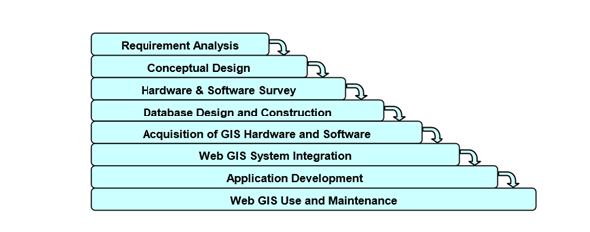

Figure 3.1: The Alesheikh GIS Development Cycle

The architecture for this project will be the three tier client-server architecture in which the map server will be the server, the database that will be used to give response to the user’s queries will be on the server side. The client will be the browser. Additionally, the user interface will act as the presentation tier, the Map Server as the application/business logic tier and Desktop GIS the data tier.

.

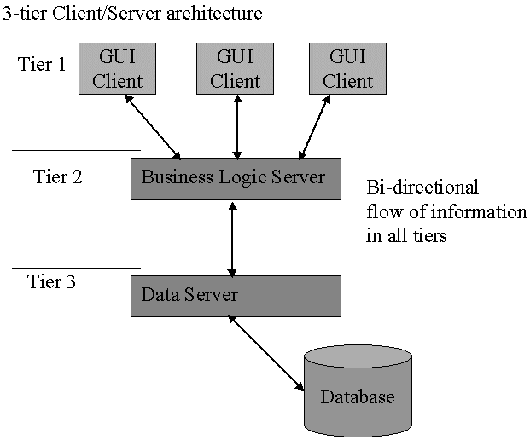

Figure 3.2: Three tier client/server architecture

The solution consists of the following functional parts:

1. **A spatial database** that can provide random access to large data sets, query processing and understands spatial relationships. Post GIS an extension of Postgre SQL will be used to create and maintain the spatial database of the NGOS in Nairobi County.
2. **A desktop software** that can provide editing and visualisation of data in the database. This will enable data management, quality control and reporting.
3. **A cartographic map renderer** that will be used to serve data from the spatial database, apply styling rules and output map images. Geoserver which reacts to web requests through open layers, to generate geographical objects dynamically will be the server side software.
4. **An application server** that will provide a programming framework where other applications can run. Apache tomcat will be used for this.
5. **A map tile server** store for pre-rendered image tiles that serves them up quickly upon request to make maps refresh faster and a web map component that can provide a map component inside a browser.

# CHAPTER 4: RESULTS

Postgis is an extension of the postgresql database was installed and the ngocom database created. Postgis was preferred for this project as it supports the effective storage and management of spatial data.

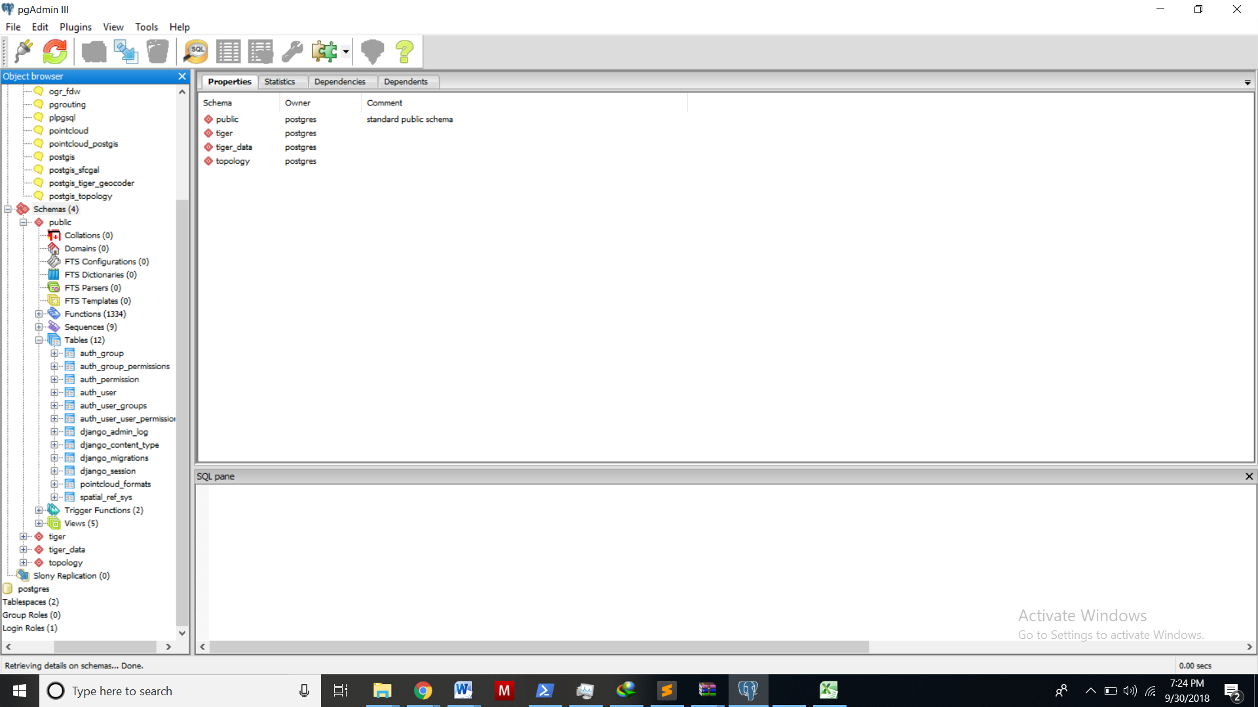

Windows power shell was used to install python version 3.7,django version 2.1.1 was installed in the life in gis virtual environment from which the development was done.The use of a virtual environment enables the installation and use of various libraries without affecting the other programs installed in the computer.The django leaflet 0.24 was als used to enable the quick display of maps from the mapserver.OSGEO was installed as it conyains libraried such as the gdal which provide a spatial environment during development.Psycopg2 version 2.7.5,an adapter that enables the programme to interact with the postgis database was also installed.

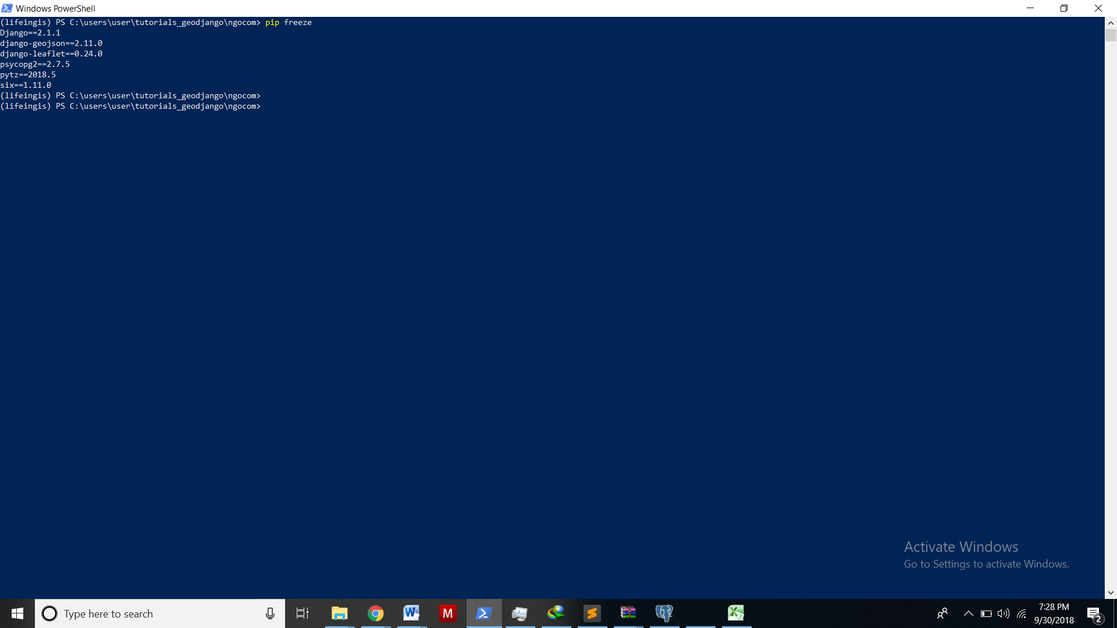

Sublime text was used as the text editor of choice. This is because it is simple to use and makes it easy to navigate from one display to another. It also easily provides a visual of which folder one is working from on the left pane.

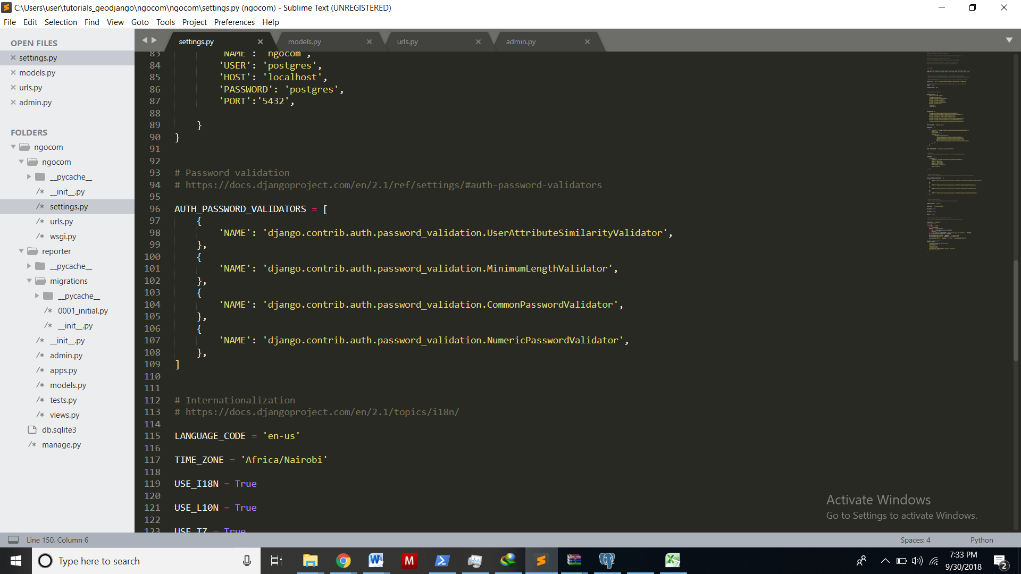

The django admin is the back end of the ngocom system. It allows for direct interaction with the database. To access it one has to create a super user and password in the windows PowerShell. It allows for creation of additional groups and users.

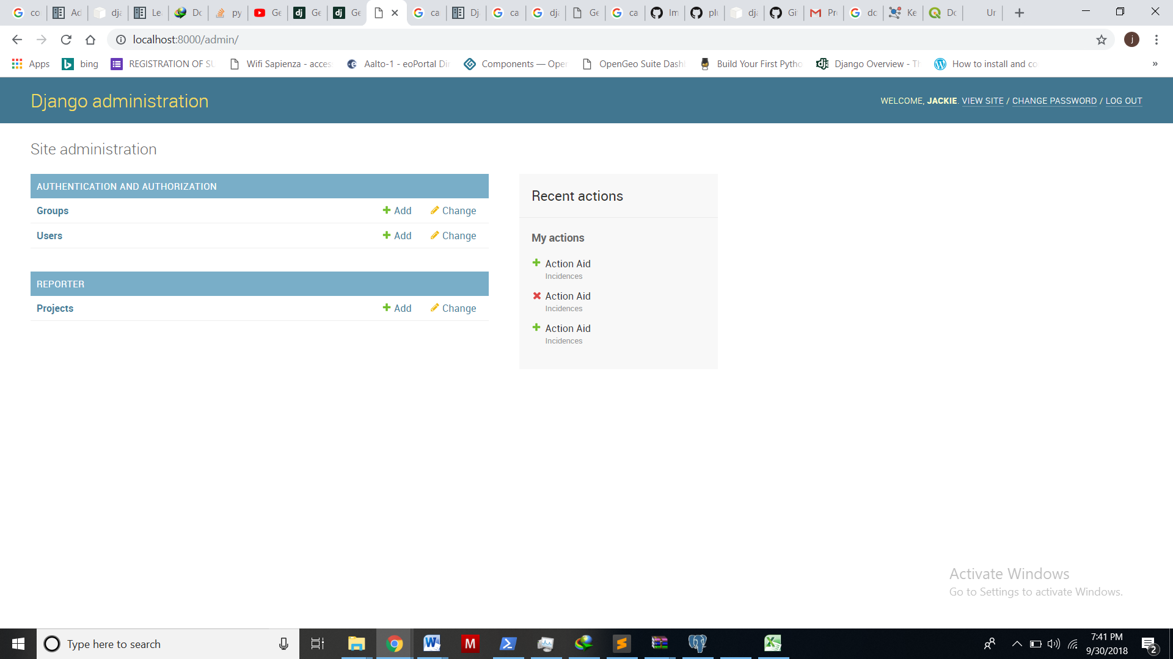

The super-user will be able to upload a csv file of projects,their location and ngos responsible into the database.The administrator interface also provides for a way in which the super user can add data manually to the database by selecting a location.

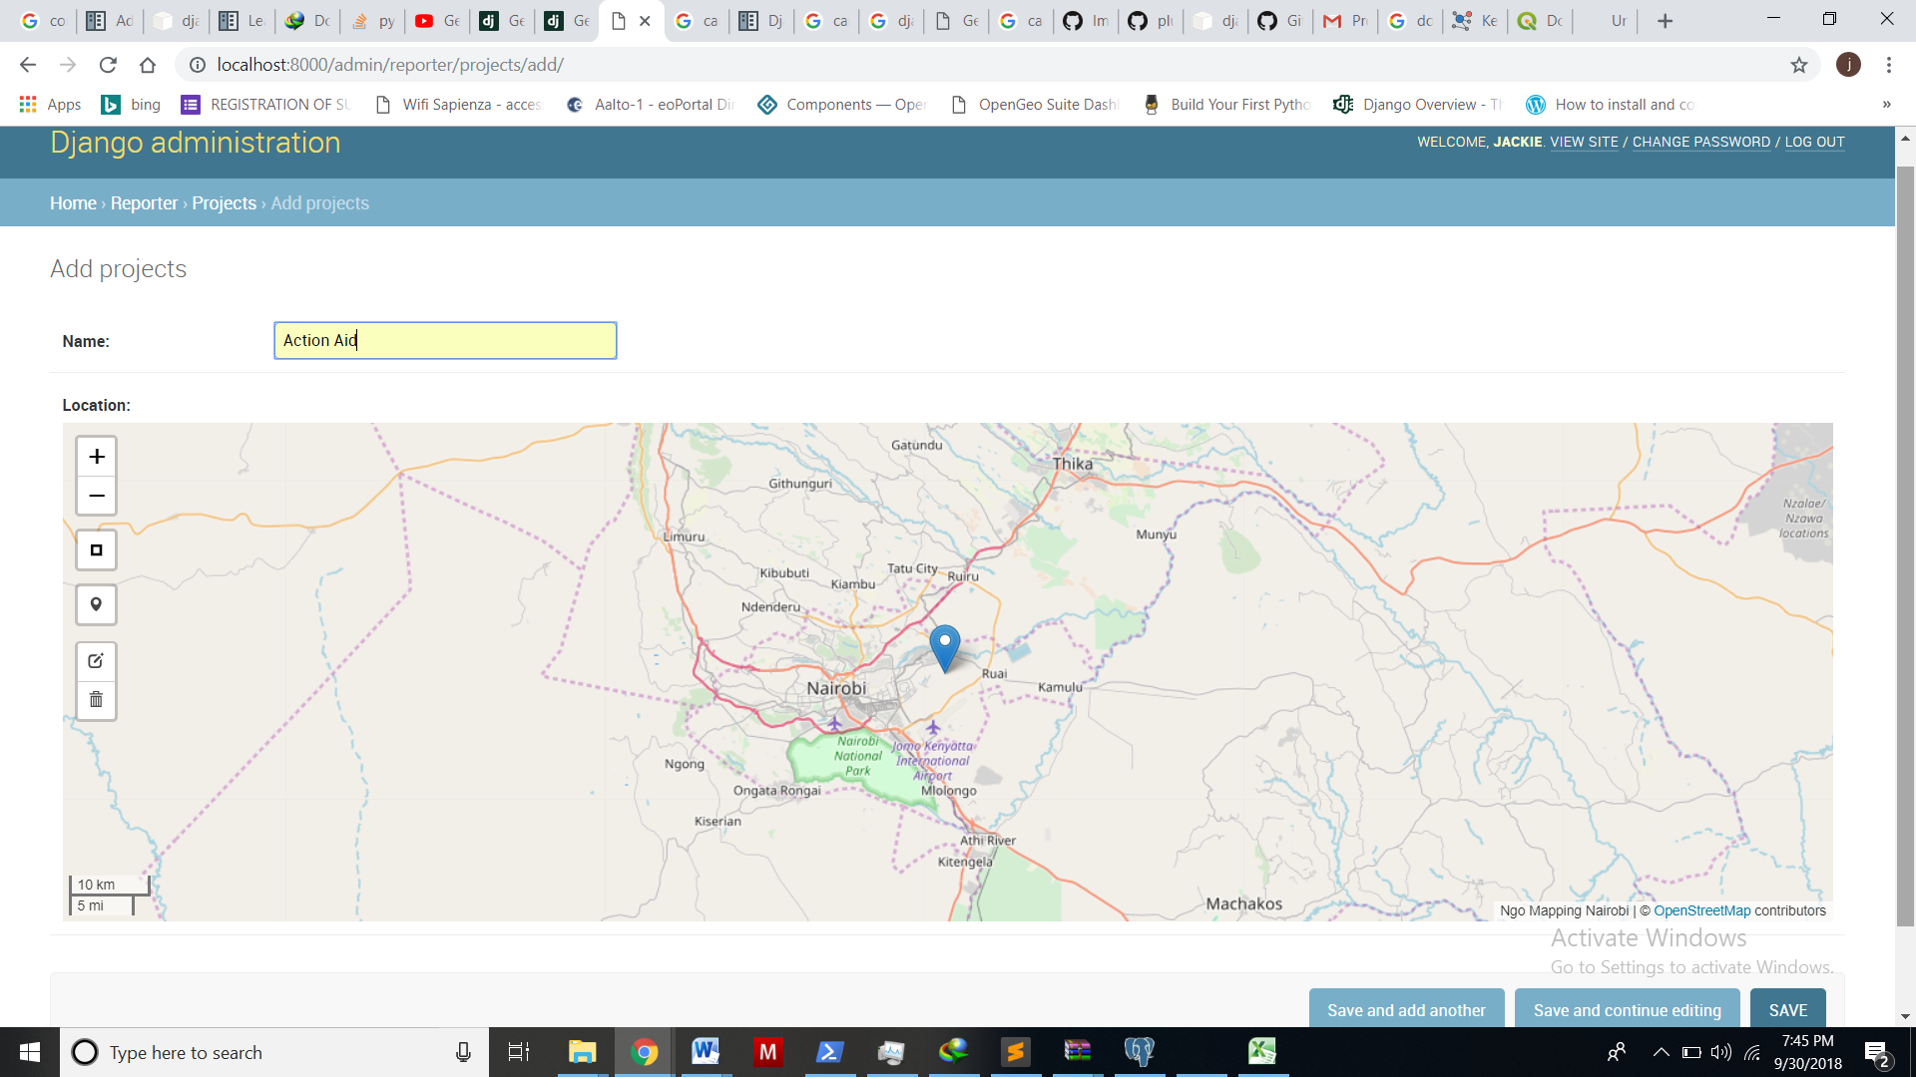

# PROJECT WORKPLAN

|  |  |  |  |  |  |  |  |  |  |  |  |  |  |  |
| --- | --- | --- | --- | --- | --- | --- | --- | --- | --- | --- | --- | --- | --- | --- |
| **ACTIVITY/WEEK** | **WK 1** | **WK 2** | **WK 3** | **WK 4** | **WK 5** | **WK 6** | **WK 7** | **WK 8** | **WK 9** | **WK 10** | **WK 11** | **WK 12** |  |  |
| **USER REQUIRMENTS** |  |  |  |  |  |  |  |  |  |  |  |  |  |
| Collecting Requirements |  |  |  |  |  |  |  |  |  |  |  |  |  |
| Research on systems |  |  |  |  |  |  |  |  |  |  |  |  |  |
| **CONCEPTUAL DESIGN** |  |  |  |  |  |  |  |  |  |  |  |  |  |
| Database Design |  |  |  |  |  |  |  |  |  |  |  |  |  |
| Website Design |  |  |  |  |  |  |  |  |  |  |  |  |  |
| **H/WARE & S/W SURVEY** |  |  |  |  |  |  |  |  |  |  |  |  |  |
| Hardware Survey |  |  |  |  |  |  |  |  |  |  |  |  |  |
| Software Survey |  |  |  |  |  |  |  |  |  |  |  |  |  |
| **IMPLEMENTATION** |  |  |  |  |  |  |  |  |  |  |  |  |  |
| Database Construction |  |  |  |  |  |  |  |  |  |  |  |  |  |
| Web Application Development |  |  |  |  |  |  |  |  |  |  |  |  |  |
| Report Writing |  |  |  |  |  |  |  |  |  |  |  |  |  |
| **DEPLOYMENT & TESTING** |  |  |  |  |  |  |  |  |  |  |  |  |  |
| Testing |  |  |  |  |  |  |  |  |  |  |  |  |  |

# PROJECT BUDGET

|  |
| --- |
| **Adm number:F56/88421/2016** |
| **Name: JACKLINE RATENG** |
| **BUDGET ITEMS** | **Budget** *(in Ksh)* | **TOTAL Budget** *(in Kshs)* |
| **1. Equipment** |  |  |
| i)Laptop –Core i7 ,RAM 64 GB | 60,000 |  |
| ii)Printer | 10,000 |  |
| iii)Internet | 20,000 |  |
| ***Subtotal Equipment*** | ***90,000*** | ***90,000*** |
| **2. Travel and meeting costs** |  |  |
| i)Meetings with supervisor | 10,000 |  |
| ii)Fieldwork | 40,000 |  |
| ***Subtotal Travel  and meeting costs*** | ***50,000*** | ***140,000*** |
| **3. Consumables** |  |  |
| i)Printing | 1,000 |  |
| ii)Airtime | 10,000 |  |
| iii)Binding costs | 2,000 |  |
| ***Subtotal Consumables*** | ***13,000*** | ***153,000*** |
| **4. Knowledge Exchange costs** |  |  |
| i)Group Discussions and Brain storming | 5,000 |  |
| ii)Purchase of journals and publications | 5,000 |  |
| ***Subtotal Knowledge   Exchange costs*** | ***10,000*** | ***163,000*** |
| ***T O T A L*** |  | ***163,000*** |

# REFERENCES

Alesheikh, A., Helali, H. and Behroz, H. (2002) *Web GIS: Technologies and Its Applications*. Symposium on Geospatial Theory, Processing and Applications, Vol. 15, Ottawa, 2012

Ananda F., Prof. David K. and Dr. Moses N. (2016) *Towards a new methodology for web GIS development* International Journal of Software Engineering & Applications (IJSEA), Vol.7, No.4, July 2016

Bebbington A. (2004) *Progress in Human Geography*: NGOs and uneven development: geographies of development intervention.

Cavaco R., Rui S., Mário A., Miguel C. (2010) *Rapid GIS Development:a mode* Portugal: International Conference on Geographic Information Science -based approach focused on interoperability.

Chemngetich M. (2009) Discourses on Civil Society in Kenya-*The prospects of civil society driven change in Kenya* 3: 20-31.

Daily Nation Kenya (2015) (KHRC vs NGO Coordination board 495 of 2015):October 15 2015.

Dupuy K., Ron J. and Prakash A. (2015), *Who Survived? Ethiopia Regulatory Crackdown on Foreign-Funded NGOs,* inReview of International Political Economy

##### Jillo R. A. (2009) NGO Law in Kenya The International Journal of Not-for-Profit Law Volume 11, Issue 4, August 2009

[Julia P.](http://www.merip.org/author/julia-pitner) *Middle East Research and information Projects* 2017 at www.merip.org.mer/mer214/ngos-dilemmas [accessed on 10 March 2018]

Kamau N., *civil-society-condemns-attempted-raid-and-deregistration-of-human-rights- organisations* 18 August 2017 <https://www.civicus.org/index.php/media-> resources/media-releases/2918-kenya-civil-society-condemns-attempted-raid-and- deregistration-of-human-rights-organisations[accessed on 12 March 2018]

Kristina A. (2016) Civil Society Under Pressure 4. January 2016 at [https://ke.boell.org/2016/01/04/civil-society-under-pressure[accessed](https://ke.boell.org/2016/01/04/civil-society-under-pressure%5baccessed) 8 March 2018]

[MacWright](http://macwright.org/) T., and [E. van Zummeren](http://www.evanzummeren.com/) (2010), *The Hitchhacker’s Guide To Tiled Maps* www.liedman.net/tiled-maps

Mas´o J., K.P., Julia, N (2010): *Open GIS Web Map Tile Service Implementation Standards*. Open Geospatial Consortium Specification.

# Najjar F. (2017),*Why is Egypt's new NGO law controversial?* Aljazeera 31/05/2017 [ accessed on August 23,2018]

O'Reilly T. (2004) O’Reilly Media, [https://www.oreilly.com/pub/a/web2/archive/what-is-web- 20.html?page=5 [accessed](https://www.oreilly.com/pub/a/web2/archive/what-is-web-%0920.html?page=5%20%20%5baccessed) on August 23, 2018]

Peters, Ina (2011), *The Belo Monte Dam: Prime Example of a Successful Civil Society in Brazil*

Drinhausen K. and Günter S. GIGA Focus Latin America, 9, online: <www.giga- hamburg.de/giga-focus/lateinamerika>.

Plewe B. (1997) GIS Online: Information Retrieval, Mapping, and the Internet Santa Fe, USA: Wordpress, First Edition.

Rousse M. (2015), *Web 2.0* <https://whatis.techtarget.com/definition/Web-20-or-Web-2> [accessed on March 10,2018]

Samuel K., Eunice K. *NGOs received Sh6b funds from unknown sources*- report 15 September 2015 at [www.nation.co.ke/news/NGOs-receive-funds-unknown-sources/1056-](http://www.nation.co.ke/news/NGOs-receive-funds-unknown-sources/1056-) 2871462-gka0bz/index.html [acesses on 8 March 2018]

The London School of Economics and Political Science (LSE), *How to Measure Civil Society*, 2001, <http://fathom./se.ac.uk/features/122552> [accessed on March 10, 2018]

Wanjiru G. *Role of civil society in implementing constitution*- *the* *struggle-continues* October 24, 2015 at [www.katibainstitute.org/role-of-civil-society-in-implementing-](http://www.katibainstitute.org/role-of-civil-society-in-implementing-) constitution-the-struggle-continues-by-by-wanjiru-gikonyo [accesed on March 10,2018]

Wischermann, J. (2013), *civil societies supporting authoritarian regimes. The case study Vietnam,* in:Political quarterly , special issue, 47, 324-347.

World Bank, (1997) *Handbook on Good Practices for Laws Relating to NGOs,* The International Center for Not-for-Profit Law.

Brockington D. and Banks N., October 2017, *Changes in Expenditure, Income and Income Sources for Development NGOs based in the UK* <https://mappingdevelopmentngos.wordpress.com/> [accessed on August 21, 2018]

[Karamoja Resilience Support Unit (KRSU)](https://www.karamojaresilience.org/publications/category/karamoja-resilience-support-unit) *Karamoja NGO Mapping Report,* November 2016*,* [Karamoja Resilience Support Unit (KRSU)](https://www.karamojaresilience.org/publications/category/karamoja-resilience-support-unit)